**Bank Loan Report – Query Doc**

**KPI’s**

**Total Loan Applications**

SELECT COUNT(id) AS Total_Loan_Applications

FROM bank_loan_data;



**Month-To-Date Total Loan Applications**

SELECT COUNT(id) AS MTD_Total_Loan_Applications

FROM bank_loan_data

WHERE MONTH(issue_date) = 12 AND YEAR(issue_date) = 2021;



**Previous Month-To-Date Total Loan Applications**

SELECT COUNT(id) AS PMTD_Total_Loan_Applications

FROM bank_loan_data

WHERE MONTH(issue_date) = 11 AND YEAR(issue_date) = 2021;



**Total Funded Amount**

SELECT SUM(loan_amount) AS Total_Funded_Amount

FROM bank_loan_data;



**MTD Total Funded Amount**

SELECT SUM(loan_amount) AS MTD_Total_Funded_Amount

FROM bank_loan_data

WHERE MONTH(issue_date) = 12 AND YEAR(issue_date) = 2021;



**PMTD Total Funded Amount**

SELECT SUM(loan_amount) AS PMTD_Total_Funded_Amount

FROM bank_loan_data

WHERE MONTH(issue_date) = 11 AND YEAR(issue_date) = 2021;



**Total Received Amount**

SELECT SUM(total_payment) AS Total_Received_Amount

FROM bank_loan_data;



**MTD Total Received Amount**

SELECT SUM(total_payment) AS MTD_Total_Received_Amount

FROM bank_loan_data

WHERE MONTH(issue_date) = 12 AND YEAR(issue_date) = 2021;



**PMTD Total Received Amount**

SELECT SUM(total_payment) AS PMTD_Total_Received_Amount

FROM bank_loan_data

WHERE MONTH(issue_date) = 11 AND YEAR(issue_date) = 2021;



**Average Interest Rate**

SELECT ROUND(AVG(int_rate)*100,2) AS Avg_Interest_Rate

FROM bank_loan_data;



**MTD Average Interest Rate**

SELECT ROUND(AVG(int_rate)*100,2) AS MTD_Avg_Interest_Rate

FROM bank_loan_data

WHERE MONTH(issue_date) = 12 AND YEAR(issue_date) = 2021;



**PMTD Average Interest Rate**

SELECT ROUND(AVG(int_rate)*100,2) AS PMTD_Avg_Interest_Rate

FROM bank_loan_data

WHERE MONTH(issue_date) = 11 AND YEAR(issue_date) = 2021;



**Average Debt-to-Income Ratio (DTI)**

SELECT ROUND(AVG(dti)*100,2) AS Avg_DTI

FROM bank_loan_data;



**MTD Average Debt-to-Income Ratio**

SELECT ROUND(AVG(dti)*100,2) AS MTD_Avg_DTI

FROM bank_loan_data

WHERE MONTH(issue_date) = 12 AND YEAR(issue_date) = 2021;



**PMTD Average Debt-to-Income Ratio**

SELECT ROUND(AVG(dti)*100,2) AS PMTD_Avg_DTI

FROM bank_loan_data

WHERE MONTH(issue_date) = 11 AND YEAR(issue_date) = 2021;



**GOOD LOAN ISSUED**

**Good Loan Percentage**

SELECT

(COUNT(CASE WHEN loan_status = 'Fully Paid' OR loan_status = 'Current' THEN id END) * 100.0)

/

COUNT(id) AS Good_Loan_Percentage

FROM bank_loan_data;



**Good Loan Applications**

SELECT COUNT(id) AS Good_Loan_Applications

FROM bank_loan_data

WHERE loan_status = 'Fully Paid' OR loan_status = 'Current';



**Good Loan Funded Amount**

SELECT SUM(loan_amount) AS Good_Loan_Funded_Amount

FROM bank_loan_data

WHERE loan_status = 'Fully Paid' OR loan_status = 'Current';



**Good Loan Received Amount**

SELECT SUM(total_payment) AS Good_Loan_Received_Amount

FROM bank_loan_data

WHERE loan_status = 'Fully Paid' OR loan_status = 'Current';



**BAD LOAN ISSUED**

**Bad Loan Percentage**

SELECT

(COUNT(CASE WHEN loan_status = 'Charged Off' THEN id END) * 100.0)

/

COUNT(id) AS Bad_Loan_Percentage

FROM bank_loan_data;



**Bad Loan Applications**

SELECT COUNT(id) AS Bad_Loan_Applications

FROM bank_loan_data

WHERE loan_status = 'Charged Off';



**Bad Loan Funded Amount**

SELECT SUM(loan_amount) AS Bad_Loan_Funded_Amount

FROM bank_loan_data

WHERE loan_status = 'Charged Off';



**Bad Loan Received Amount**

SELECT SUM(total_payment) AS Bad_Loan_Received_Amount

FROM bank_loan_data

WHERE loan_status = 'Charged Off';



**LOAN STATUS GRID VIEW**

SELECT

loan_status,

COUNT(id) AS Total_Loan_Applications,

SUM(total_payment) AS Total_Received_Amount,

SUM(loan_amount) AS Total_Funded_Amount,

AVG(int_rate * 100) AS Interest_Rate,

AVG(dti * 100) AS DTI

FROM bank_loan_data

GROUP BY loan_status;

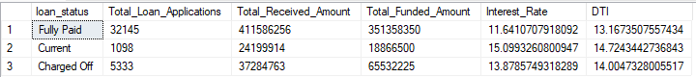

SELECT

loan_status,

SUM(total_payment) AS MTD_Total_Received_Amount,

SUM(loan_amount) AS MTD_Total_Funded_Amount

FROM bank_loan_data

WHERE MONTH(issue_date) = 12 AND YEAR(issue_date) = 2021

GROUP BY loan_status;

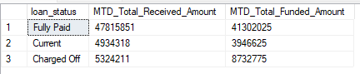

**OVERVIEW CHARTS**

**Monthly Trends by Issue Date**

SELECT

DATENAME(MONTH, issue_date) AS Month,

COUNT(id) AS Total_Loan_Applications,

SUM(loan_amount) AS Total_Funded_Amount,

SUM(total_payment) AS Total_Received_Amount

FROM bank_loan_data

GROUP BY DATENAME(MONTH, issue_date), MONTH(issue_date)

ORDER BY MONTH(issue_date);

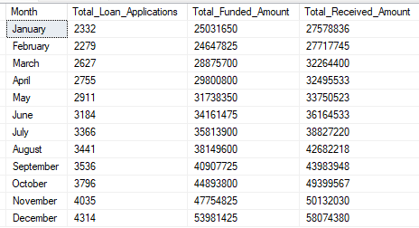

**Regional Analysis by State**

SELECT

address_state,

COUNT(id) AS Total_Loan_Applications,

SUM(loan_amount) AS Total_Funded_Amount,

SUM(total_payment) AS Total_Received_Amount

FROM bank_loan_data

GROUP BY address_state

ORDER BY SUM(loan_amount) DESC;

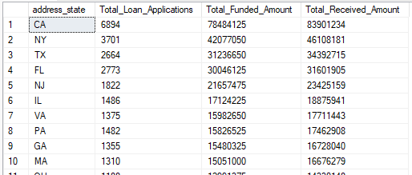

**Loan Term Analysis**

SELECT

term,

COUNT(id) AS Total_Loan_Applications,

SUM(loan_amount) AS Total_Funded_Amount,

SUM(total_payment) AS Total_Received_Amount

FROM bank_loan_data

GROUP BY term

ORDER BY term;



**Employment Length Analysis**

SELECT

emp_length,

COUNT(id) AS Total_Loan_Applications,

SUM(loan_amount) AS Total_Funded_Amount,

SUM(total_payment) AS Total_Received_Amount

FROM bank_loan_data

GROUP BY emp_length

ORDER BY COUNT(id) DESC;

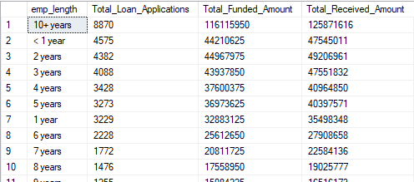

**Loan Purpose Breakdown**

SELECT

REPLACE(LOWER(purpose),'_',' ') AS Loan_Purpose,

COUNT(id) AS Total_Loan_Applications,

SUM(loan_amount) AS Total_Funded_Amount,

SUM(total_payment) AS Total_Received_Amount

FROM bank_loan_data

GROUP BY purpose

ORDER BY COUNT(id) DESC;

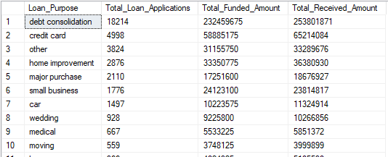

**Home Ownership Analysis**

SELECT

home_ownership,

COUNT(id) AS Total_Loan_Applications,

SUM(loan_amount) AS Total_Funded_Amount,

SUM(total_payment) AS Total_Received_Amount

FROM bank_loan_data

GROUP BY home_ownership

ORDER BY COUNT(id) DESC;

